MGT 6203 Group Project Proposal

**TEAM INFORMATION (1 point)**

**Team #:63**

**Team Members:**

1. Ronald Mosness; rmosness3

Director of Business Analytics for The Denver Post, B.S. Finance/Accounting, Putting together a data/analytics reporting team to better track all the dashboards and reports going out to our sales teams.

2. Priyal Patel; ppatel645

Health Economics and Trends Analyst at Ascension, Bachelor of Healthcare Administration from Texas State University, responsible for creating Tableau dashboards and providing insights on KPIs for the population health team.

3. Raja Kolli; rkolli31

QA Lead at Hogarth - WPP. Leading a team of QA engineers to test and automate the websites and retail apps.

4. Benjamin Boyajian; bboyajian3

BA in Mathematics, data scientist at Healthfirst, analyzes medical claims data using Python, SQL, and R

5. Christopher Nelson; cnelson311

Business Data Analyst at doTERRA, B.S. Statistics, data analysis, forecasting and development of reports to various leaders to provide discoveries and suggestions for the business.

**OBJECTIVE/PROBLEM (5 points)**

Project Title: Comparing Historical Bitcoin Prices to the SP500

**Background Information on chosen project topic:**

The trading prices for Bitcoin are erratic and unpredictable. While Bitcoin is an investment, similar to the stock market, Bitcoin is touted as being unregulated and decentralized. However, theories swarm that Bitcoin and the traditional stock market are related and impact one another.

**Problem Statement (clear and concise statement explaining the purpose of your analysis and investigation):**

To determine whether a relationship exists between the upward and downward trends of the stock market and Bitcoin’s trading price.

**State your Primary Research Question (RQ):**

Is the performance of Bitcoin and its trading price linked to the stock market performance of top companies?

**Add some possible Supporting Research Questions (2-4 RQs that support problem statement):**

1. Does the price of bitcoin increase/decrease after an increase/decrease in the SP500?

2. If the answer to #1 is yes, how long does it take for one trading platform to react to the other?

3. If the answer to #1 is no, are the two platforms inversely related?

**Business Justification:** **(Why is this problem interesting to solve from a business viewpoint? Try to quantify the financial, marketing, or operational aspects and implications of this problem, as if you were running a company, non-profit organization, city, or government that is encountering this problem.)**

Understanding whether Bitcoin trading trends are related to the S&P 500 will enable investors to know whether Bitcoin is genuinely an independent investment tool or whether it, like so many other traditional investment opportunities, is ultimately linked together and impacted by common trends. If Bitcoin is truly independent, investors may be able to hedge against losses by implementing this investment strategy. However, if the two are related, the same precautions taken in traditional investing must be applied to investing in Bitcoin.

**DATASET/PLAN FOR DATA (4 points)**

**Data Sources (links, attachments, etc.):**

<https://www.kaggle.com/datasets/sudalairajkumar/cryptocurrencypricehistory/versions/3?resource=download&select=coin_Bitcoin.csv>

<https://www.kaggle.com/datasets/andrewmvd/sp-500-stocks>

**Data Description (describe each of your data sources, including screenshots of a few rows of data):**

The Bitcoin data set shows the dates and the high and low prices for the day as well as the market cap. The S&P 500 dataset shows the price at the close of the trading day.

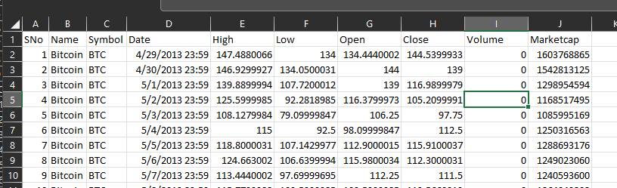

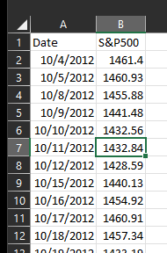

**Key Variables: (which ones will be considered independent and dependent? Are you going to create new variables?** **What variables do you hypothesize beforehand to be most important?)**

To determine the price of Bitcoin, we will have our closing price as our dependent variable. Our independent variables will mainly be our S&P 500 Index Score, as well as the different prices per day. Our main research question is to see whether the S&P Index will have an effect on Bitcoin prices, so we hypothesize that that will be the most important independent variable that we have. We might create new variables based on average prices, seasonal trends, and coin mining that could be part of our analysis.

**APPROACH/METHODOLOGY (8 points)**

**Planned Approach (In paragraph(s), describe the approach you will take and what are the models you will try to use. Mention any data transformations that would need to happen. How do you plan to compare your models? How do you plan to train and optimize your model hyper-parameters?))**

Forecasting is a critical element of running a successful business. Improved forecasts save companies money and allow them to more quickly adapt to shifting preferences.

In this project, we develop a model that addresses these issues while forecasting the Bitcoin trading trends and S&P 500 trends and to see if they both are correlated. We will try to use linear regression model (Log transformations to make it linear if needed)

We plan to compare models using the R-squared, adjusted-r-squared, MSE, MAE and summary statistics. We will do data preprocessing, use ensemble techniques to reduce bias and variance to boost the accuracy of models. We will also be using the Ridge, Lasso and/or Elastic net models to optimize the model features and results.

We will try to use GridSearchCV and RandomSearchCV to optimize our model hyper-parameters. We will train, test and validate our models by splitting data in 70/15/15 ratio and use cross validation to make sure we are not overfitting the model by using the same data from training and testing to validate the model.

**Anticipated Conclusions/Hypothesis (what results do you expect, how will your approach lead you to determine the final conclusion of your analysis) Note: At the end of the project, you do not have to be correct or have acceptable accuracy, the purpose is to walk us through an analysis that gives the reader insight into the conclusion regarding your objective/problem statement.**

It is expected that Bitcoin will be highly correlated to the S&P 500 and susceptible to the same market-wide risk as the S&P. We could use this conclusion to predict Bitcoin prices to help investors understand the potential investment opportunity for Bitcoin as the S&P 500 has a more detailed history and Bitcoin is relatively new as an investment.

**What business decisions will be impacted by the results of your analysis? What could be some benefits?**

Investing is a big part of successfully growing any business or your personal wealth and Bitcoin has become one of the most volatile but also fastest growing investments in history. With this analysis, we can benefit by concluding whether Bitcoin is susceptible to market trends or is truly independent from market-wide risk. With this information, we can successfully take precautions based on whether it follows market-wide risks or if a whole new investment strategy must be created around Bitcoin. If Bitcoin and the S&P 500 are correlated, we could use this information to predict Bitcoin prices for potential investors as the S&P 500 has a far more detailed history than the newer introduction of Bitcoin.

**PROJECT TIMELINE/PLANNING (2 points)**

**Project Timeline/Mention key dates you hope to achieve certain milestones by:**

Data preparation and cleanup: 10/21/2022

Creation of models / Ensemble techniques / Model Tuning: 11/08/2022

Analysis of model results and conclusions: 11/15/2021

**Appendix (any preliminary figures or charts that you would like to include):** 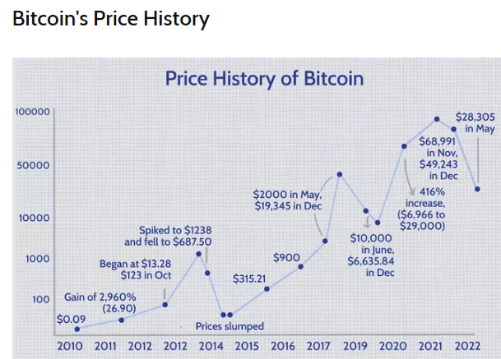

S&P 500 Price History

